Colorado Tree Coalition
CommuniTree Awards Program

The CommuniTree Awards Program recognizes individuals and organizations that epitomize the mission of the Colorado Tree Coalition through their efforts to preserve, renew and enhance Colorado’s urban and community forests. The three recognition categories and descriptions are:

- Two Distinguished Service Awards are given to (1) a professional community forester/arborist and (2) a volunteer that have contributed significantly to the health and sustainability of Colorado’s community forests in the past year.

- One Sustainable Urban Forestry Award is given to an individual, business, or organization that has fostered evolution in our use of trees and appreciation of the value of trees within our communities as a critical component of resilient and thriving places.

- One Lifetime Achievement Award is given to an individual whose work, over the course of their entire career, has unfailingly served to preserve, renew, and enhance community forests.

If you know someone you feel meets one of these categories and deserves to be recognized and honored for their efforts, please nominate them! Read on for information on the nomination and award process.

Nomination Checklist

Identify… a project, group, or individual worthy of recognition.

Submit… the completed Nomination Form via email.

Attach… a detailed description (maximum 2 typed pages) of contributions, accomplishments, and impacts.

Include… supplemental information like photos, articles, videos, or other media.

Award Presentation

Winners will be notified and details of the award presentation worked out at that point. Winners may be asked to supply additional photos and/or materials for the Awards Presentation.

Judging

Entries will be evaluated on impact, quality, innovation, stewardship, adherence to sound tree management principles, and connection to the mission of the Colorado Tree Coalition.

Awards

Each award winner will receive a hand-crafted table-top award symbolic of the grace and stature of trees and their contribution to our communities.

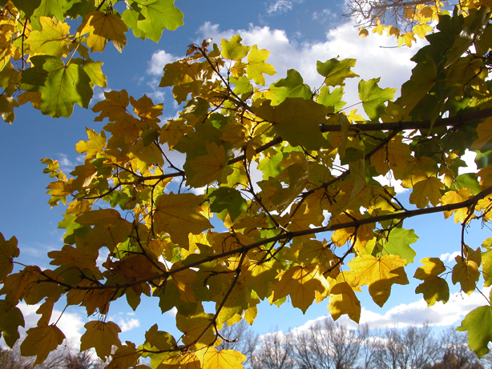

CommuniTree 2021 Nomination Form

Project/Group/Individual:

Brief Summary of Nomination (Please limit to 2 paragraphs; you may attach additional details.):

Nominated by:

Address:

City/State:

Phone:

Email:

Send Completed Electronic Package To: coloradotreecoalition@gmail.com
(Please include 2021 CommuniTree Award Nomination in the Subject Line)

Have questions? Contact us at coloradotreecoalition@gmail.com or 719-468-9499.

Deadline for 2021 submission: December 17, 2021

